Applied machine learning systems ELEC0134 20/21 report
SN: 20159465

Abstract

The scope of this assignment is the realization of various machine learning approaches on four different tasks on Image Recognition field, carried out on two provided datasets, one that is subset of the original CelebFaces Attributes Dataset (CelebA) [1] and the Cartoon Set [2]. In this work we compare the relative merits of the various approaches to advance each classification task by means of accuracy. We deal with a great variety of extracted feature descriptors for image modality followed by machine learning techniques as well as with various deep and convolutional neural networks. Initially, the up-to-date technologies in the fields of image recognition are being thoroughly explored through bibliographical research and the most important approaches are documented. Following this, the basic principles on which our proposed approach is based, as well as the potential successful tries that are made, are presented. Finally, we propose the best-performed model for each task through plot and table comparisons, giving promising results, close to state-of-the-art, given the limitations of our project conditions. The maximum accuracies obtained on Test Data were, for Gender Classification Task 91.733%, for Emotion Detection 89.467%, for Face Shape recognition 100% and for Eye Color recognition 84.533%.

Index Terms— Machine learning; Deep learning; Convolutional networks; Classification; Face recognition; SVM; Logistic Regression; PCA; Image Augmentation

1. Introduction

Since time immemorial, face has been the most important and vital biometric feature of human beings, since it can be deemed as a highly reliable metric for distinguishing one person from another. Face attributes can give information about various properties like gender, age, ethnicity, eyes, face disfigurement, etc., each of them being linked to a different research domain on Image Processing and Machine Learning.
In this paper we survey the methods of Gender Recognition and Emotion Detection on a subset of CelebA dataset [1] as well as Face Shape Recognition and Eye color Detection on the Cartoon Set [2]. All these tasks are classification problems, each of them being thoroughly approached from various perspectives, while the purpose of each task’s elaboration is the outcome of an optimal prediction model that do not jeopardize of being distorted or overfitting by the misdirection of weak techniques and poor feature extraction, but more powerful and robust features fed on appropriate algorithms determine a fine-grained and well-generalized model.
Face attribute recognition methods are generally categorized into two groups; geometrical information and appearance-based information [6]. Geometrical information is based on features relationship such as distance, area and others between the facial units such as nose, eyes, etc., while appearance features deal with pixel patterns and intensity, where accurate locations of landmarks are not required [7]. In our work we extract appearance features through different techniques including resizing, normalizing, rescaling, as well as Facial Embeddings extraction [10] which are high-level face representations.
The remainder of the report is organized as follows. Section 2 briefly reviews some classical and state-of-the-art machine learning algorithms in face attributes classification tasks. Section 3 describes the models we used for each task, along with the rationale, while in section 4 we provide the detailed implementation of our models, including the feature extraction along with any data pre-processing and classification methods. A comparative analysis of the results obtained as a consequence of the work done for the current project is listed in Section 5. Section 6 concludes with the inferences drawn and the scope for further research.

2. Literature survey

Many different techniques for solving problems of Image classification on facial attributes have been reported in literature. Approaches may differ in the choice of feature extraction method which can be divided into two groups: a) Geometrical-based methods and b) Appearance-based methods, and in the design of the classifier, ranging from the use of SVM, Logistic Regression algorithms to the use of neural networks, deep and convoluted. In this work we focus on the appearance-based approach where every pixel of image is taken into account rather than local features.
Early works in gender classification mostly used neural networks with raw input of face images. In 1991, Colomb et al. [11] used a 900 x 40 x 900 fully connected back propagation network to feed rescaled images of size 30 X 30. Output of the hidden unit has been used as input to final neural network (SEXNET) to produce values 1 for male and 0 for female, achieving an accuracy of 91.9%. Raisamo and Makinen [13] performed gender classification on automatically detected and aligned faces from the IMM and FERET Databases. One of the findings was that the automatic face alignment methods did not increase the gender classification rates. Also, facial images were variously re-sized before any preprocessing, showing actually that the best rated model depended on the image re-sizing. The best classification rate was achieved with input raw images resized to 36x36 pixel size passing through an SVM classifier after being compared to a Neural Network model with Image pixels as input, an SVM with LBP as input and Adaboost with Haar-Like features as input. In [17] a CNN architecture with only four layers fed with raw pixel images is proposed for real-time gender classification with facial image data taken from SUMS and T&T databases. Swaminathan et al. [18], proposed a novel method to predict gender by applying various machine learning classification techniques on Facial Embeddings, which were found by passing through a pre-trained Facenet Model [19] which had also been produced by a CNN using Pretrained Inception Network’s weights. This method also helped overcoming the problems encountered in facial recognition like variance in illumination and orientation.
As far as Emotion Detection is concerned, the majority of recent methods still face challenges because of high variance of image features concerning illumination, orientation and scaling, which make necessary the stage of prenormalization before feature extraction. However, Jang et al. [21] were the first to propose a novel smiling face detection framework called SmileNet which uses a Fully Convolutional Neural Network (FCNN) to detect smiling or not in an image irrespective of varying resolution, illumination and orientation, hence without requiring pre-processing to generate a normalized input image. SmileNet can deliver state-of-the-art performance up to 95.76%, even under high variances of images. On top of that data augmentation techniques either traditional or GAN techniques [24] showed an enhanced performance dealing with the issue of overfitting.
All these techniques can be used or extended for more specified face detection and alignment tasks, such as smiling detection, face shape recognition and eye color detection.

3. Description of models

Therefore, literature shows that there is no right or wrong solution to any classification problem, but the structure and preparation of data affects in a high degree the efficiency of each method. So, in this paper we propose some models on each given task that excelled through a pipeline research Machine Learning procedure. Further details about the architecture of this procedure are provided in the next section.

3.1. Task A1: Gender Detection

For this task we selected five different classification models, some tested with different preprocessing techniques to compare and choose the best one. Accuracies of the following models on validation data are shown on Figure 1.
3.1.1. Linear Support Vector Machine (SVM)
SVM algorithm is widely used for classification problems with high dimensional data, finding an optimal separating hyperplane. The most basic way to use a SVM is with a linear kernel, which means the decision boundary is a straight hyperplane. Vapnik in 1992 [26] showed that higher dimensional input data make the classification problem easier, since as dimensions of vectors rise, their sparsity also ramps, hence facilitating the learning of separable hyperplane. Feeding the model with raw pixels of flattened downscaled image data, the accuracy achieved on validation data is 88.933%, a good estimation of gender prediction revealing a decent, may not perfect, linear relation between data. Due to computational limitation, we downscale our original image data of 218x178x3 pixels to 100x100x3, which actually is a good resolution for images.
However, an important problem that our data face is the Curse of Dimensionality. When analyzing high dimensional data on a small, not representative sample, then any model jeopardizes of overfitting, since the classifier starts learning exceptions that are specific to the training data and do not generalize well when new data is encountered. Reducing image vectors from 30000 length to 2500 PCA components, linear SVM gives an accuracy of 89.467% on validation data, bigger than this of raw image data, meaning that PCA successfully captured a significant part of the important information of original feature vectors and learned the separation hyperplane acquiring much less computational space and time.

3.1.2. Non-linear Support Vector Machine (SVM)
We also make some experiments on SVM with Gaussian RBF kernel this time. RBF kernel is used when our data are not linearly separable, so a mapping function is needed to project input space to a higher-dimensional feature space where the training set is separable. Feeding the raw pixel image train data and experimenting through some hyperparameters of RBF, we end up in accuracy scores no more than 85%, less than the one of Linear kernel.

3.1.3. Logistic Regression (LR)
Feeding the raw flattened pixel data to a Logistic Regression model with solver = ’Liblinear’, we achieve an accuracy of 88.933% on validation data. This solver was chosen due to its robustness on solving large-scale classification problems, since Linear SVM proved that our data behave better in linear problems solving algorithms. It is important to notice that LR is a linear classifier, that can be thought of as finding a hyperplane to separate positive and negative data points.
Trying to reduce high dimensionality of our raw image data we convert images from RGB to gray scale, reducing by a factor of three our feature vectors. However, the prediction accuracy of the same LR model deteriorates meaning that important information, decisive for the classification boundary gets lost. However, when applying PCA dimensionality reduction with n=2500 components, the obtained accuracy on validation data becomes 89.467%, the same as in Linear SVM-PCA model.

3.1.4. CDNN with Transfer Learning and Data Augmentation
Modern deep learning algorithms, such as the convolutional neural network can learn features that are invariant to their location in the image. A typical CNN architecture for image classification includes a set of several layers with learning weights of neurons that get amplified when affecting patterns around regions that carry meaningful information and attenuated for the less meaningful ones. First layer combines pixels into edges, second edges into patterns and so on until last layer maps patterns for high-level features into gender.
However, inspired by Schroff et al. [19], and because of having a relatively small dataset for CNN architectures, we use Transfer Learning, hence loading the pretrained model Inception-v3 from ImageNet competition [29] which has been trained on an extremely large dataset for hundreds of hours on multiple high-powered GPUs. Transfer Learning, apart from increasing performance, it considerably reduces training time, a crucial factor taking into account our computational resources limitation.
All the same, in order to improve the generalization performance and further reduce overfitting, we will use a technique called Image Augmentation [30]. Image augmentation comprises a wide range of techniques used to generate “new” training samples from the original ones by applying random jitters and perturbations on already seen images
So, the design of our CNN is as follows. Initially, the CNN model receives input images of original size 218x178x3. After loading the weights from all the layers of Inception-v3, we also add two fully connected layers of 1024 and 512 size respectively, before the sigmoid output layer of size 1 that makes the gender decision. Finally, after a learning procedure on augmented train samples, our network results in a maximum accuracy of 85.867% on validation data.

3.1.5. Linear SVM with CNN feature extraction and PCA
It is obvious that the previous model does not outperform the baseline ones, however we should elaborate on the fact that this network had extracted some important feature embeddings with deeper and more complex patterns that raw image pixels cannot represent. Therefore, we take the previous already trained CNN, discard the output layer and pass all images through this so as to downsize them and convert a (217x178x3) sized image to a (512x1) sized vector which will be the new facial features for each image. Our proposed model is to feed these extracted feature representations in a Linear SVM classifier, which finally achieves an enhanced accuracy of 92.133% on validation data. All the same, we apply the PCA technique to CNN’s facial embeddings to reduce further their dimensionality and actually we achieve, by extracting n=125 PCA components, an overall accuracy of 92.400%, ascertaining that information-rich features from 512-length embeddings, were efficiently captured by 125 PCA components.
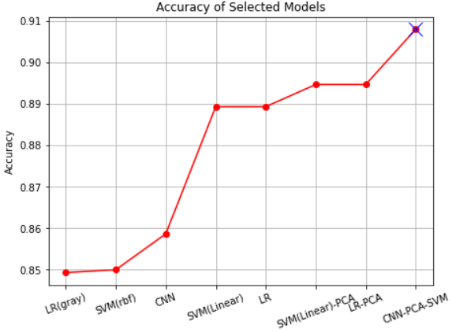
Fig. 1 Accuracies of Gender Classification models

3.2. Task A2: Emotion Detection (Smiling/Not Smiling)

In this task we delve into two main models, Logistic Regression and CNN, in which we experiment through different sizes of raw image data and model parameters, in order to learn the decision ‘boundary’ as more effectively.

3.2.1. Logistic Regression (LR)
Feeding the raw flattened pixel data of original size image (218x178x3) into a Logistic Regression model with solver = ’Saga’, we achieve an accuracy of 86.533% on validation data. This solver was chosen due to its robustness on solving large-scale classification problems. The computational resources and time needed for the algorithm to learn totally depend on the dimensionality of samples, making this model time consuming, though. Hence, we try to reduce the input data dimensionality, without losing decisive information. First, we convert images from RGB scale to Gray (1-D), reducing dimensionality by a factor of 3 and as we can see on figure 2, reducing the runtime by a factor of almost 4 while retaining almost the same information as this of RGB model. Following we experiment with the rescaling of image data to 100x100 pixels, both with RGB and Gray scale and as we can see in Figure 2, both learn well, while the gray scale slightly outperforms. Adding to the downscaled gray image data further feature extraction preprocess, PCA with n=500 components achieves almost the same accuracy = 86.4% as when we exploit the original image features with dimension=116412, proving that PCA captured the same information with much less computational resources and time. We can infer from Table 1 that the model fed with PCA features extracted from gray scale downsized image data gives as good performance as RGB original scaled data do, differing only in thousandths, while fitting time of model is reduced by a factor of 250, an extreme difference in computational resources needed. Hence, this model is the most well performed between the aforementioned ones. Figure 2 depicts the relationship between the three most robust LR models in accordance to their runtime.
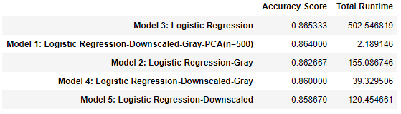
Table 1 Accuracy Scores and Runtime of LR models

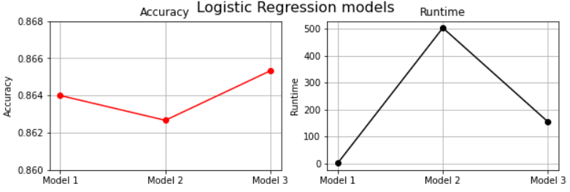
Fig. 2 Accuracy and Runtime of best performing LR models

3.2.2. CNN
After experimenting with various CNN architectures, we opt for two salient ones that achieve good generalization and prediction accuracy. Both models have same architecture, which is drawn in Figure 3, but with different dimension input data. The first one is training over downscaled RGB image data, while the other one over downscaled gray image data. For training the CNNs the Adam optimizer and the binary crossentropy loss metric are used. After 8 and 15 epochs respectively, that learning procedure stops, a maximum accuracy of 87.333% for CNN with RGB data and 88% for CNN with Gray data on validation set are achieved.

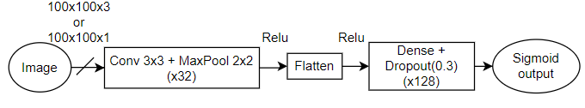
Fig. 3 CNN model Architecture

So, on Figure 4 we compare the three best performing models’ accuracy on Validation Set, which are Logistic Regression with PCA Downscaled Gray Input Data and the two aforementioned CNNs. CNN with Gray Input Data outperforms the other two.

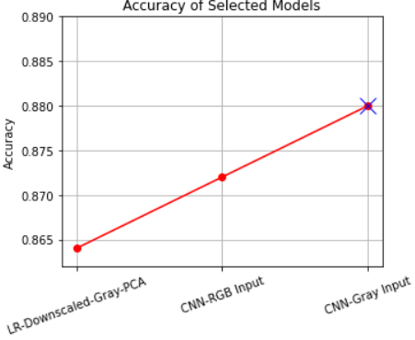
Fig. 4 Best Models’ Accuracy on Smiling Detection

3.3. Task B1: Face Shape Recognition
This task deals with a multi-class classification problem. The raw image dataset consists of cartoon images with size 500x500x3. It is obvious that this feature dimension is quite large and the amount of available data could not generalize accurately a model taking into account all this dimensionality, besides given the computational limitation we could not maintain all this dimensionality. Hence after downscaling our samples to 110x110x1 dimensions and applying feature selection to remove all zero variance features, we pass the training set through a Linear SVM, giving a perfect classification accuracy of 100% to validation data. This outcome reveals that our data are perfectly linearly separable and downscaled gray input pixel data can fit perfectly in a simple robust linear algorithm like SVM.

3.4. Task B2: Eye Color Recognition

Since our dataset consists of cartoon images that are all aligned and do not need any configuration or detection method to be applied, but simple models perform well, we propose the following model. Before fitting our data to the trainable algorithm, we crop each and every image to standard pixels so as to obtain a frame around the eyes, since every sample is the frontage of the cartoon centralized and on top of that we downscale the image from 500x500 to 110x110 pixels for simplicity without affecting the eye color, just sharpens the edges of image. After extracting n=300 PCA components from our 4500 length features, we fit our train data to a Logistic Regression model with Liblinear solver, penalty=’l1’ and C=1 (default values) and achieve an accuracy on validation data of 84.267%. Figure 5 depicts all tested models not only with LR, but also with SVM.

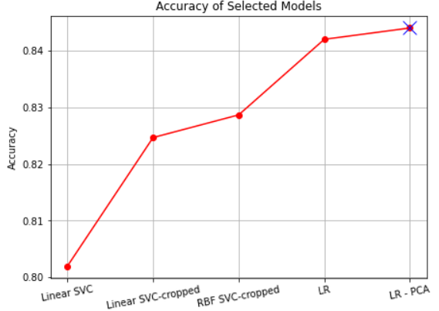
Fig. 5 Accuracies of Eye Color Recognition models

4. Implementation

So, in this paper we propose a pipeline research Machine Learning procedure which is applied in each task with the view to develop an optimal classification model. Specifically, at the beginning some baseline approaches with default parameters are carried out, e.g. SVM and Logistic Regression, fed with raw data in order to compare each method’s efficiency with the baseline one, in terms of accuracy besides complexity. Afterwards, hyperparameter fine-tuning is implemented either manually or through Grid-Search so that we infer the best baseline algorithm according to their performance on validation set. Following this, some preprocessing methods are applied to raw data in order to discard redundant information before being fed into the best baseline algorithm, so as to result in which preprocessing technique outperforms, based on the accuracy of validation data classification. Last, for tasks A1 and A2, CNN architectures on raw data are tried out with some image augmentation techniques, not only as Classification models, but also as feature extraction methods which convert raw image pixel data to high level facial embeddings to be fed into the initial best performing baseline model. After all, comparing the final models’ efficiency on how much they enhance the accuracy on validation data classification, but also the generalization error (GE) between training and unseen data accuracy we settle on the best model. To prevent overfitting, but also keep track of the GE we split each dataset into train, validation and test set at a rate of 70:15:15 respectively. Cross-validation method would be ideal for elaborating on best learning techniques for tasks A1 and A2, however, due to the limitation of computational resources in our devices, we keep up with the train-dev-test splitting technique.

4.1. Task A1: Gender Detection

To begin with, after splitting our CelebA dataset into train, dev, test set with 3500, 750, 750 samples respectively, and mapping label 1 to males and label -1, after replacing it with 0 just for compatibility with CNNs later, to females, we extract for each sample a feature vector. Initial images are given in a resolution of 218x178x3; however, before any training task we perform downscaling to 100x100x3 for the sake of computational efficiency. Also, we normalize image pixels from ranging between 0-255 to a range of 0-1, because smaller feature values may need smaller weight values of trainable models, hence boosting the learning process or just not burdening it with high values. Last, before any processing, we look for missing values in our dataframes and also if they are balanced to avoid being biased in favor of a specific class.

4.1.1. Baseline Classifiers
First of all, after flattening the 3D feature image into 3000-dimensions, we feed them to a Linear SVM, loaded from Scikit-learn library, with its default values. While this model has a good accuracy of 88.933% on validation data, we experiment through SVM with RBF kernel, in case the decision boundary works better with non-linear combinations of data. Training different models with all the combinations of values C in [1, 10, 100] and gamma in [0.001, 0.001, 0.1], we can see that none of these combinations exceed the linear kernel’s performance, while all models with gamma = 0.001, irrespective of the value in C achieve an accuracy of 85%, pretty close to the linear one. This happens because the lower the gamma value, the less curvy is the decision boundary and converges more to a linear hyperplane. Following, after experimenting with various solver parameter of Logistic Regression algorithm, we end up that solver =’Liblinear’ on same raw pixel data as before gives the same performance as Linear SVM.

4.1.2. Preprocessing Techniques
In this step, we try to exclude redundant information that do not contribute to our classification task or even worsens its performance. Initially, we convert RGB images (3D) to gray scale (1D), ending up with 10000 length image vectors. However, the previous Logistic Regression fed with these vectors achieves a performance of 84.933% on validation data, worse than RGB vectors model performance.
Secondly, a feature selection process is following, in which after examining the distribution of all features’ variance, we test the performance on the previous Linear SVM model by setting some arbitrarily variance thresholds which remove the features with variance lower than this. However, the best performance on dev set is given by setting the threshold=0.06 and it reaches 68%. This happens supposing because some meaningful dimensions for the separation of samples are discarded, thus we quit this method. After, we experiment on the aforementioned best performing baseline models after applying PCA feature extraction method. Experimenting through various PCA n_components in {150, 200, 250, 300, 500, 700, 1000, 1500, 2000, 2500, 3000, 3500} we select n =2500 which on Linear SVM achieved the best accuracy of 89.467%, while Figure 6 reveals the performance of each n_components. Although this model seems to overfit on training data, for this value of PCA component, we achieve a good trade-off between Generalization Error and Accuracy metric.

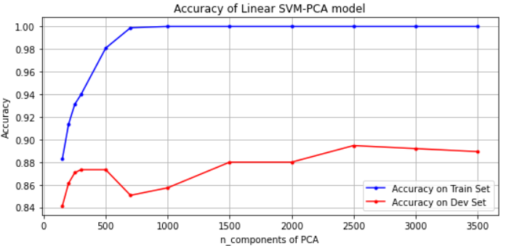
Fig. 6 Learning Curve of PCA components in Linear SVM

4.1.3. Convolution Networks
Additionally, after experimenting with some CNN architectures with 2, 3, and 4 convolutional layers, number of feature maps ϵ {32,64,128,256}, optimizers like SGD, Adam, Adagrad with different hyperparameters and some further parameters imported from Keras library, always fed on downscaled image input data (100x100x3), the best accuracy reached during a period of 30 epochs training, on validation data was 76% while on training data was almost the same 77.7%. These models misperformed not only because of weak architectures but also because the number of training samples wasn’t representative of feature dimensions. So, as we proposed in paragraph 3.1.5, we perform an Image Augmentation preprocessing technique to raw original sized image data before being fed to the pretrained Inception-v3 Network which was loaded from Keras library. Leaving out the last fully connected layer of Inception-v3 model, we load all the other 311 layers, setting them to non-trainable in order to avoid overfitting and add two fully connected layers of 1024 and 512 size respectively with ReLU activation and an intermediate dropout layers of 0.4 dropout rate to avoid overfitting too. The output of the network is derived by a final sigmoid dense layer which send very negative inputs close to 0 and very positive close to 1 in order to implement the classification. Trying different optimizers, like Adam which missperforms leading to overfitting and SGD with learning rate = 0.0001 that shows very slow convergence, we end up with an SGD with learning rate = 0.001 and momentum= 0.9. As loss function we opted for binary crossentropy. For Image Augmentation, we flow images in batches of 100 using a data generator imported from Keras in which we set some small values for the transformation of images to represent real-life circumstances. Hence, ImageDataGenerator class “intercepts” the original data, randomly transforming it, and then returning it to the neural network for training through the fit_generator function. After 10 epochs, as we can see on figure 7, our model stops learning new pattens, and loss on validation data starts worsening, so we stop learning procedure at 10 epochs, resulting in a maximum accuracy of 85.867% on validation data and 85.8% on train data, suggesting that the model is probably not over or underfit.
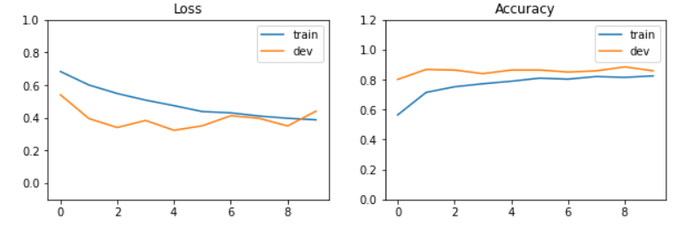
Fig. 7 Learning Curves for proposed CNN

4.1.4. CNN – SVM
Following, using the previous model as feature extractor, we discard the last layer and pass all images through the rest network so as to downsize them and convert a (217x178x3) sized image to a (512x1) sized embedding vector. So, before feeding the training data to the best performing Linear models, we apply a further preprocessing technique, PCA. Experimenting with PCA n_components ϵ {100, 125, 150, 175, 200, 250, 300, 350} we select n = 125, since for this value we achieve the best accuracy on validation set and the less Generalization Error. The accuracy achieved of this model on training and validation data reaches around 95% and 92.400%, respectively, meaning that we avoided overfitting on training set, since both accuracies are high and close enough.

4.2. Task A2: Emotion Detection (Smiling/Not Smiling)
In this task we followed a similar approach as Task A1, since our model is built on the same dataset.

4.2.1. Logistic Regression
First of all, after flattening the 3D original feature image of size 218x178x3 into 116412-dimensions, we feed them to a Logistic Regression (LR) model with all the possible solvers ϵ {'newton-cg', 'lbfgs', 'liblinear', 'sag', 'saga'} to fine tune the best baseline classifier. Grid Search pipeline on training data revealed ‘saga’ solver as the best performing achieving an accuracy of 86.533% on validation data. The same model is applied to downscaled raw image data with 3000 features giving an inferior accuracy of 85.867%. We also experiment through some SVM models with linear and rbf kernels with some combinations of C and gamma values, albeit they do not outperform LR models besides their runtime exceeds by far this of LR because of Support Vectors computation, hence we keep up with preprocessing techniques on LR.
Subsequently, we convert downscaled images from RGB scale to Gray (1-D), for the sake of runtime efficiency. We experiment on the aforementioned best performing LR model applying the PCA method on downscaled gray image data, with n_components in {200, 300, 400, 500, 600, 1000}, whose performance is depicted on Figure 8. We chose n =500 which achieved the best accuracy=86.4% with a decent GE between training and validation data where train data have not overfitted on model.

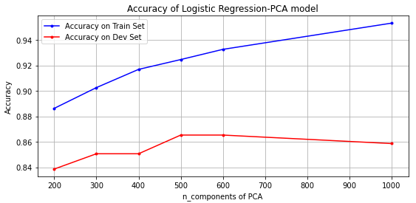
Fig. 8 Learning Curve of PCA components in LR

4.2.2. CNN
We delve into some CNN architectures tested with both RGB and gray downscaled image data. Experimenting with 1, 2 and 3 convolutional layers (CV), number of feature maps ϵ {32,64,128}, optimizers like SGD, Adam, Adagrad with different hyperparameters, kernel size of 3 and 5, dropout rates between CV ranging in [0.3, 05] and 1,2 and 3 dense layers with dimensions ϵ {128, 1024}, we end up on the network architecture of Figure 3. Adam optimizer and the binary crossentropy loss metric were best performed.
It is important to highlight that every layer’s weights were not initialized with some random value or zero, but we used the truncated normal initializer that generates weights from a normal distribution with mean=0 and stddev=0.1 so as the training do not stack in a local optima. Also, with dropout rate=0.3 we achieved better results, avoiding strong dependencies between the adjacent layers. Model with downscaled gray image data on the aforementioned network outperforms reaching an accuracy of 97.3% for training data and 88% for validation data after training for 15 epochs. As we can see in figure 9, after 15 epochs, our model stops learning new pattens, or has reached a local optima if not the best, and loss on validation data starts worsening contrary to train loss, while train accuracy ameliorates since model starts overfitting, so we stop learning procedure at 15 epochs where train and dev loss has a decent difference. We also experimented through data augmentation technique in order to better converge during training, albeit the performance was worse than even baseline models, do not exceeding 64%.

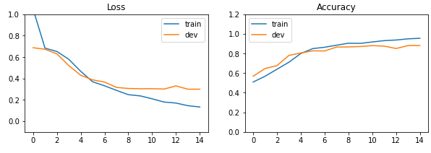
Fig. 9 Learning Curves for proposed Pretrained CNN

4.3. Task B1: Face Shape Recognition

The carton dataset that is used in this task comprises 10000 samples, from which 7500 will be used as training samples, 1500 as validation set and the remained 1500 as test set. Each cartoon sample is assigned a distinct value between 0 to 4, indicating its face shape. The dataset is totally balanced while there are no missing values. As we explained in 3.3 section, we downscale original image size of 500x500x3 to 110x110x1, removing also the RGB scale since color is not needed for face shape identification. Also, since the background of each cartoon image is everywhere white and of course do not carry meaningful information for our task, we apply feature selection setting a variance threshold equal to zero to remove the common pixels of all samples that have the zero price. Therefore, from an image with 500x500x3 features we end up in 6725 sized vectors. Afterwards we pass these high dimensional features into a Linear SVM, where we get an accuracy of 100% on validation data, explaining that our extracted features are perfect linearly separable in high dimensional space.

4.4. Task B2: Eye Color Recognition

Like previously we follow the same preparation technique. We downscale images to 110x110x3, however this time retaining the RGB dimensions since we need the eye color for the classification and apply feature selection to remove background pixels, ending up in 20175 sized cartoon features. Feeding these features of training set into a Linear SVM and a Logistic Regression with default values we get an accuracy of 80.2% and 80.8% respectively. To further remove superfluous information and since cartoon faces are perfectly centralized, we crop images removing 40 pixels each up and down and 30 pixels each right and left, in order to keep only the frame around eyes, obtaining final vectors of 4500 size. Following, we fine tune the baseline algorithms fed with the preprocessed data. First, we try some values for parameter C ϵ {1, 10, 100} in Linear SVM, while for SVM with RBF kernel we experiment through the combinations of values C in {1, 10, 100} and gamma in {1e-2, 1e-3, 1e-3}. The best performance was achieved by SVM with RBF and gamma = 0.0001, C = 100 which means misclassified data points are highly penalized, with 82.867% accuracy on validation data. Second, we fine-tune Logistic Regression with values of C in {0.01, 0.1, 1, 10, 50}, penalty in {‘l1’, ‘l2’} and solver = ‘liblinear’, obtaining an accuracy of 84.2% for C=1 and penalty = ‘l1’. This model performs better with Lasso Regularization (‘l1’ penalty) since it shrinks the less important feature’s coefficients to zero thus, removing some redundant feature and this works well when we have a large number of features.
Finally, we further apply PCA dimensionality reduction to the aforementioned LR model, with n= 300 being the optimal number of PCA components according to figure 10, where accuracy on training data seems quite decent and certainly model did not overfit on train data.

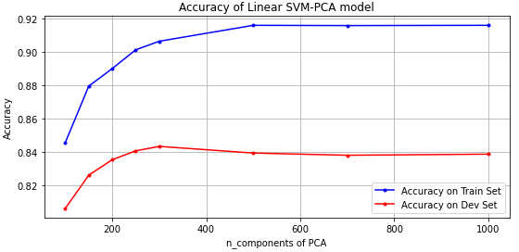
Fig. 10 Learning Curve of PCA components in LR

5. Experimental Results and Analysis

Now that we have figured out the rationales behind our models, we present how they perform on unseen data and explain this behavior. On table 2, we can see that all models perform equally good in unseen data as they do in validation ones. This means that our models don’t overfit neither on training data nor indirectly on validation data for which we inject knowledge on models through the optimization of hyper-parameters based on validation set performance.

Task | Model | Train Acc | Val Acc | Test Acc
A1 | CNN-PCA-SVM | 0.94743 | 0.91867 | 0.91733
A2 | CNN | 0.97300 | 0.88000 | 0.89467
B1 | SVM | 1 | 1 | 1
B2 | PCA-LR | 0.90043 | 0.84400 | 0.84533

Table 2 Accuracy of all models on each dataset

It is also important to highlight the efficiency of dimensionality reduction techniques. The figures 11, 12, 13 prove that models trained on less and more representative features outperform these trained on original features, thus demonstrating robustness and stability with respect to scale and degree of facial detail. Taking into account that all the four tasks deal with linearly separable classification problems and the fact that PCA separate the samples most under the linear distance measure, we can substantiate the good performance of this technique. Features selected by PCA are not always optimal as we can see in their learning curves. Not all numbers of survived features are informative.
Generalization Error is a huge topic which is bounded by many factors. Some of them concern the size and the quality of training samples. In Task A1 we can see that our model succeeded in minimizing the GE, while avoiding overfitting on training set where accuracy was around 95% and also performance on unseen data increased. Contrary to the other models where GE remained stable, in Task A1 we took advantage of image augmentation and pretrained model which injected meaningful information in our feature extractor. In Tasks A2 and B2, as Figure 12 and 13 depict, GE remained stable, however the best fitted models increased accuracy prediction not only to training and validation data but also to unseen, meaning that we proposed more robust models, where the better fitting of training samples extracted more meaningful knowledge.
Moreover, we can infer for Task A1 and A2 that given this dataset we don’t need many layers to achieve a good performance since we don’t have too much training data. For tasks B1 and B2 that our data have some structure, NN are not necessary for this problem. NN are mostly used when we have unstructured data.
On Task A2 we experimented through data augmentation to enrich our training dataset making it as close to the ‘real world’ as possible. However, the dataset that is given to us does not actually reflect the real world. Simple linear algorithms have shown that our given images can be linearly separable in high dimensions, proving that our dataset is already "clean" and faces are well oriented and normalized so an image augmentation is redundant; thus, training set is becoming worse for our validation data derived from the given ‘clean’ dataset, which explains the poor performance.
As far as Task B1 is concerned, our model classified all train, dev and test sets perfectly achieving always an 100% accuracy. However there as some possible reasons why that happened. First, our training and test/dev data are too much alike compared to practical scenarios. This is quite possible, since cartoons are created by a finite variety of characteristics that are replicated just though different combinations. The artwork components are divided into a fixed set of layers that define the boundaries of each face attribute [32]. Also, there is a chance that data from the train set have leaked into the test and validation one, which means the whole dataset consists of duplicates (at least), so the estimator knows the labels of incoming data of test/dev sets. Finally, it is important to highlight that Cartoon dataset is quite big, hence models learn many possible patterns that could appear in unseen data, acquiring a more robust performance.
For task B2, the best accuracy achieved on validation data was 84.4%, an almost perfect accuracy if we take into account the high number of samples that wear sunglasses and hence it is impossible to classify them correctly, since eye color is an independent variable from every other feature on face and cannot be predicted under sunglasses.
Last but not least, it is of paramount importance to report that all final best performing models were trained in much less runtime than the baseline ones as we can see in Figure 12, requiring much less computational time and space, proving the need for keeping only informative features and also that training samples must be representative of feature vectors dimensionality.
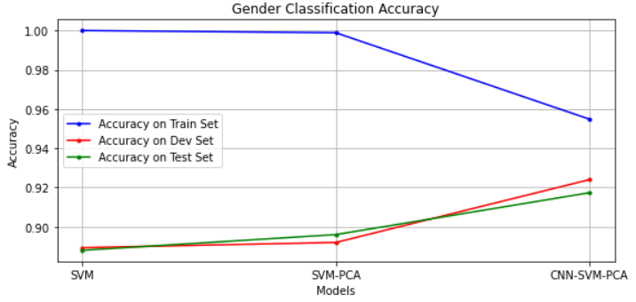
Fig. 11 Performance of baseline and final model on Task A1

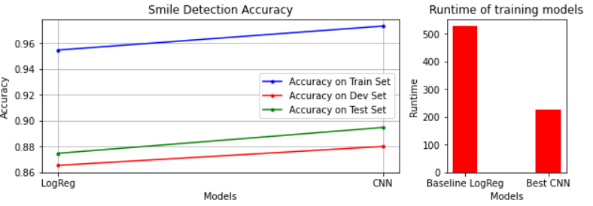
Fig. 12 Performance of baseline and final model on Task A2

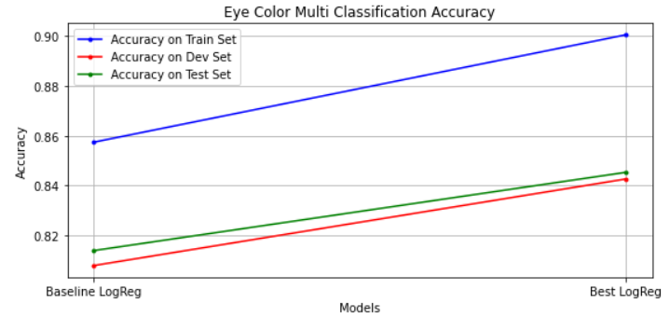
Fig. 13 Performance of baseline and final model on Task B2

6. Conclusion

In a nutshell, for all classification tasks we extracted appearance features representations which deals with pixel patterns that showed a good linearity in high dimensional space through Linear SVM, LR and some CNN networks. This project also provides insight on how dimensionality reduction preprocessing methods can boost the performance of models and save redundant computations. Another strength of this project and specific in Task A1 is that it proves that instead of treating image pixels as features, but learning facial embeddings through neural networks provides more robust classification predictions.
However, in the current work, the CelebA dataset size is relatively small, hindering models’ performance, contrary to Cartoon dataset which consists of structured images. Hence, the performance of tasks A1 and A2 approaches could be better understood by using a larger dataset. Additionally, face alignment and hence facial units’ detection, such as mouth detection would be challenging, since our images do not present huge variations of illumination and orientation of faces. Finally, a computer vision preprocessing on Cartoon Set for removing samples that wear sunglasses would enhance our model’s performance since the perturbation caused to learning model because of these ‘noisy’ samples would be removed.

12. References

[0] A.B. Smith, C.D. Jones, and E.F. Roberts, “Article Title,” Journal, Publisher, Location, pp. 1-10, Date.
[1] Yang, Shuo, Ping Luo, Chen-Change Loy, and Xiaoou Tang. "From facial parts responses to face detection: A deep learning approach." In Proceedings of the IEEE international conference on computer vision, pp. 3676-3684. 2015.
[2] https://google.github.io/cartoonset/
[6] Ghojogh, Benyamin, Saeed Bagheri Shouraki, Hoda Mohammadzade, and Ensieh Iranmehr. "A fusion-based gender recognition method using facial images." In Electrical Engineering (ICEE), Iranian Conference on, pp. 1493-1498. IEEE, 2018.
[7] A. S. Razavian, H. Azizpour, J. Sullivan, and S. Carlsson. Cnn features off-the-shelf: an astounding baseline for recognition. arXiv preprint arXiv:1403.6382, 2014.
[10] Schroff, Florian, Dmitry Kalenichenko, and James Philbin. "Facenet: A unified embedding for face recognition and clustering." In Proceedings of the IEEE conference on computer vision and pattern recognition, pp. 815-823. 2015.
[11] B. A. Golomb, D. T. Lawrence, and T. J. Sejnowski. Sexnet: A neural network identifies sex from human faces. Advances in Neural Information Processing Systems, 3:572577, 1991
[13] Makinen and R. Raisamo (2008), “Evaluation of gender classification methods with automatically detected and aligned faces,”IEEE Trans-actions on Pattern Analysis and Machine Intelligence, vol. 30, no. 3
[17] Tolba S., Invariant gender identification, Digital Signal Processing, vol 11, no. 3, pp.441-470, 2001.
[18] Swaminathan, Avinash, Mridul Chaba, Deepak Kumar Sharma, and Yogesh Chaba. "Gender Classification using Facial Embeddings: A Novel Approach." Procedia Computer Science 167 (2020): 2634-2642.
[19]Schroff, D. Kalenichenko, and J. Philbin (2015), “Facenet: A unified embedding for face recognition and clustering,”2015 IEEE Conferenceon Computer Vision and Pattern Recognition (CVPR)
[21] Jang, Youngkyoon, Hatice Gunes, and Ioannis Patras. "SmileNet: registration-free smiling face detection in the wild." In Proceedings of the IEEE International Conference on Computer Vision Workshops, pp. 1581-1589. 2017.
[24] Perez, Luis, and Jason Wang. "The effectiveness of data augmentation in image classification using deep learning." arXiv preprint arXiv:1712.04621 (2017).
[26] Boser, Bernhard E., Isabelle M. Guyon, and Vladimir N. Vapnik. "A training algorithm for optimal margin classifiers." In Proceedings of the fifth annual workshop on Computational learning theory, pp. 144-152. 1992.
[29] Tsang, S. H. "Inception-v3–1st Runner Up (Image Classification) in ILSVRC 2015." (2015).
[30] Bloice, Marcus D., Christof Stocker, and Andreas Holzinger. "Augmentor: an image augmentation library for machine learning." arXiv preprint arXiv:1708.04680 (2017).
[32] https://arxiv.org/pdf/1711.05139v6.pdf

The code is provided on GitHub project: https://github.com/xeniakal/AMLS_20-21_SN20159465

